The Power of Graffiti

Superhero graffiti artist, Banksy once said, “Graffiti is one of the few tools you have if you have almost nothing. And even if you don't come up with a picture to cure world poverty you can make someone smile while they're having a piss” (Banksy). This powerful quote can be directly applied to Mexico, a struggling country with intense political, social, and cultural issues. For nearly 70 years up until the twenty-first century, the Institutional Revolutionary Party known as the PRI (a nationalist-socialist party) held power uninterruptedly in Mexico (Nevaer, 28-29). As Nevaer puts it, “the entire country was run as if it were an enormous hacienda, with the president as the plantation master…suitable for a nation that was mostly rural, and not quite industrialized” (29). As the twentieth century came to an end, however, the Mexican people demanded Democracy. The PRI were not ready to give up power so they took a stand in Chiapas and Oaxaca, the southernmost impoverished states (Nevaer 19). It was in Oaxaca where the PRI’s ways were still in effect. One of the most protested issues there was the broken education system. The teachers (mostly women) were underpaid, schools had poor infrastructure and the children were malnourished. Ulises Ruiz, the governor of Oaxaca was to blame for this. In the May 2006, the teachers organized a strike in order to protest against these injustices (Nevaer, 30-33). This strike brought ignited a further conflict that lasted almost seven months.

On October 27, 2006, Ruiz’s police forces fired into a non-violent crowd and killed three people: a teacher, a journalist, and a local resident who admired what the teachers were trying to accomplish (Nevaer 47). Eventually, similar events that involved police opening fire on peaceful protesters led to people accusing Governor Ruiz of a murderer through the power graffiti across Oaxaca. The graffiti was influential, aggravating and politically charged. Its graphical essence comments on larger social structures and cultural issues such as power, politics, and gender.

One of the most powerful graffiti featured in Nevaer’s article portrays Ulises Ruiz as a potbelly Nazi ruler (figure 2). Both graphical and calligraphy graffiti can have powerful effects on the viewer. Graphical graffiti, nonetheless, is easier to understand than calligraphy graffiti; it allows the viewer to connect with it in greater depth. For example, if the graphical depiction of Ulises Ruiz as a Nazi was replaced with, “Ulises Ruiz es un Nazi”, the calligraphy would still get the message across, however, it would cancel out any further connections with the viewer. The fact that the graffiti illustrates Ruiz as a Nazi allows the viewer to comment and make connections to other political issues within the Mexican government.

On December 1, 2012, Enrique Peña Nieto, a member of the Institutional Revolutionary Party (PRI) became the 57th president of Mexico. His nomination, conversely, went down as one of the most controversial in Mexican history. Over the course of his presidency, he has accomplished almost nothing. Peña Nieto’s negative impact on Mexico in turn, allows viewers to connect Peña Nieto to the graphical representation of Ulises Ruiz as a Nazi. In a way, one can almost cut and paste Peña Nieto’s head on Ruiz’s graffiti and still make it work. The reason the viewer can create these connections is due to the fact that Peña Nieto’s actions towards the government somewhat reflect those of a dictator. For example, before Peña Nieto came into office, the value of the peso was significantly higher than what it is today. Since Peña Nieto, the value of the peso has decreased drastically. To put things into perspective, twelve pesos used to be equivalent to one U.S dollar. Today, it takes twenty pesos to complete one U.S dollar. The inflation Peña Nieto has caused ties back to the Nazi representation of Ulises Ruiz because, after WWII, Nazi leader, Adolf Hitler was to blame for Germany’s inflation.

In addition to Peña Nieto’s controversial presidency, some Mexican citizens strongly believe he is also accountable for the disappearances of forty-three male students in Guerrero Mexico. In 2014, 43 students from a high-level rural school mysteriously went missing. Kirk Semple, a New York Times writer wrote an article about this incident. In her article, she explains what happened the bus driver that was driving the students witnessed. The night of the disappearances, Semple states, “Municipal police officers encircled the bus, detonated tear gas, punctured the tires and forced the college students who were onboard to get off. ‘We’re going to kill all of you,’ the officers warned, according to the bus driver. A policeman approached the driver and pointed a pistol at his chest. ‘You, too,’ the officer said. With a military intelligence official looking on and state and federal police officers in the immediate vicinity, witnesses said, the students were put into police vehicles and taken away. They have not been seen since” (Semple). The motive for their abduction is still unknown. Although some believe the masterminds behind this terrible act were the mayor of the town, Jose Luis Abarca and his wife, others believe the government, including Peña Nieto, were behind the whole thing. This tangled mess strongly reflects the Ulises Ruiz Nazi persona. The Nazi government conducted similar operations, except they targeted different kind of people.

In other cases, Peña Nieto and some of Mexico’s state governors have been accused of being the most corrupt politicians in Mexico. During the Peña Nieto era, approximately twenty-two governors have committed crimes and atrocities. Javier Duarte de Ochoa, a good friend of Peña Nieto, served as the governor of the state of Veracruz from 2010-2016. During his time as a governor, Peña Nieto praised Duarte de Ochoa claiming that Duarte de Ochoa was an exemplary representation of what a governor should be like. Earlier this year Duarte de Ochoa was accused of several crimes including theft and murder. One year into office, nearly thirty-five dead bodies were found tortured near the building where Duarte de Ochoa was holding a meeting in the town of Boca del Rio. To prevent further investigation on the dead bodies, Duarte de Ochoa broke up the Boca del Rio police force investigation. In addition, there has also been a large number of missing journalist and just a couple of months ago, Duarte de Ochoa was arrested in Guatemala for stealing from Veracruz. Touching back to the topic of graffiti, one can easily see how the Ulises Ruiz Nazi graffiti can comment on Duarte de Ochoa. Adolf Hitler was seen as a corrupt leader around the world; the same can be said about Peña Nieto and Javier Duarte de Ochoa.

Another two pieces of graffiti that comment on larger social structures and cultural issues in Mexico illustrate women in despair. The first one (figure 1) portrays a woman on her knees, looking as if she has given up on a cause. Above her, appear the words, “Levantate Pueblo!”, trying to motivate the town as a whole to stand up. The other piece of graffiti (figure 3) illustrates older women holding what appears to be a baby; surrounding her, are the words, “…PARA NOSOTROS NADA”. These two pieces of graffiti are quite similar to each other. They give the viewer an impression that they could have been created by women because of their graphical content. Again, the graphical essence of these pieces is important because it adds power and allows the viewer to get a better understanding of the context. The calligraphy component of the both of these pieces could not stand by itself because it would take away the feminine aspect. Because of the women illustrations, however, the viewer is able to make connections to the oppression that women go through in Mexico.

Since 1993, a large number of women (mostly teenagers) have been murdered around the city of Juarez. ABC News reports that many of them go to Juarez to work in the town's factories, known as maquilladoras. They state that, “the official toll is 260 women killed since 1993, but local women's groups believe the actual number is more than 400. Many of the victims — the Chihuahua state government says 76 — have the hallmarks of serial killings: they were raped, some had their hands tied or their hair cut or their breasts mutilated. Bodies have been found with their heads crushed or even driven over by a car” (ABC News). The targeted women have one thing in common, they are all hard working and contribute to society. Authorities claim that the people committing these crimes are Mexican citizens, still, activists are skeptical because the killings continue even after the suspects have been arrested. For example, two bus drivers were arrested for supposedly raping and killing eight women. According to ABC News, however, “The bus drivers, Victor Garcia Uribe, 29, and Gustavo Gonzales Meza, 28, later claimed that the police had used torture to force them to make false confessions. The local newspaper, El Diario, printed photographs of wounds and burn marks on the men's legs and stomachs. Gonzalez said that he was also burned on his genitals, and that police threatened to kill his family if he told anyone about the torture”. If the Mexican government is somehow involved with the killing of these women, then there is a distinct connection between Ulises Ruiz’s graffiti and the graffiti of the women. The connection between these graffiti arises because the topic of genocide comes into play. Over the course of his ruling, Hitler killed millions of Jewish people. Similarly, the Mexican government is doing the same but is instead targeting a specific gender. It could be a way of keeping women oppressed, preventing them from gaining any kind of power.

In conclusion, we can see how the different forms of graffiti featured in Nevaer’s article can have an impact on the way the viewer connects with it. The graphical graffiti is more informative and allows the viewer to comment on other social structures and cultural issues revolving around Mexico. Going back to Banksy’s quote, we can now see why his words can be directly applied to Mexico.

-Marco Antonio Gonzalez

Works Cited

Banksy. Banging your head against a brick wall. United Kingdom: Weapons of Mass Disruption, 2001. Web.

Semple, Kirk. "Missing Mexican Students Suffered a Night of 'Terror,' Investigators Say." The New York Times. The New York Times, 24 Apr. 2016. Web. 06 May 2017.

News, ABC. "Who Is Killing the Women of Juarez?" ABC News. ABC News Network, n.d. Web. 06 May 2017.

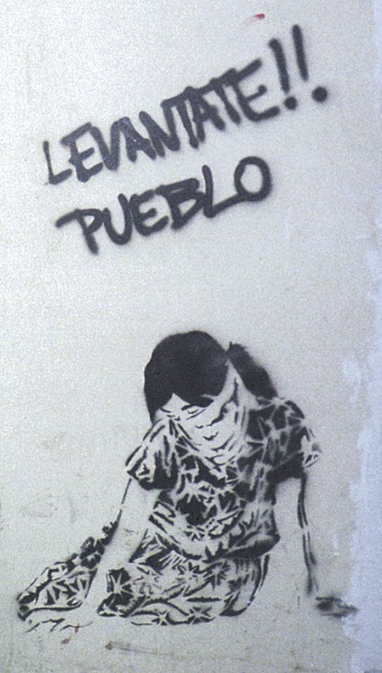 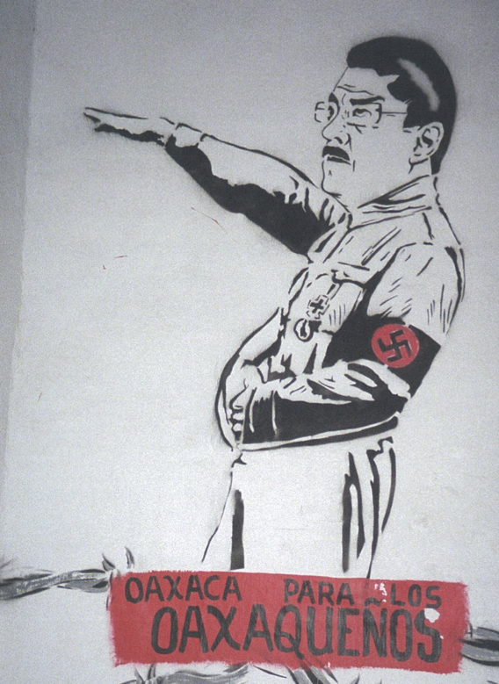

(Figure 1) (Figure 2)

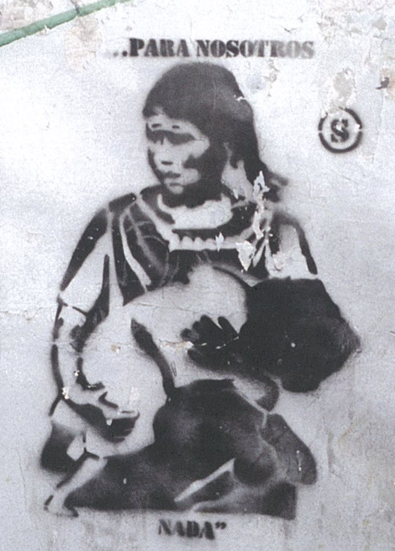 (Figure 3)